

**American International University-Bangladesh (AIUB)**

Department of Computer Science

Faculty of Science & Technology (FST)

**Coffee Shop Billing Management System**

**Semester: Fall 25-26**

|  |  |  |
| --- | --- | --- |
| ***Group: 07*** | | ***Section: N*** |
| **SL** | **Student Name** | **Student ID** |
| 1 | FUAD HASAN | 23-51947-2 |
| 2 | MD. TOFAYEL HOSSAIN | 23-51928-2 |
| 3 | SARKER LAMIA YEAMIN | 23-51926-2 |
| 4 | NAFISA ANJUM TITHI | 23-51723-2 |

**Table of Contents**

1. Project Proposal 03

1.1 Background to the Problem 03

1.2 Selection of Process Model 04

2. Software Requirements Specification (SRS) / PRD 05

2.1 Scopes and Features 05

2.2 User Story Table 07

2.3 Requirements Traceability Matrix 14

2.3.1 Functional Requirements 15

2.3.2 Non-Functional Requirements 16

3. Software Design 18

3.1 System Deisgn 18

3.2 UI Deisgn using Figma 20

4. Git Workflow 27

5. Software Testing 29

6. Conclusion 47

1. **PROJECT PROPOSAL**
   1. **Background to the Problem**

In the modern food and beverage industry, coffee shops have become essential social and business hubs. However, many small and medium-sized coffee shops in our region continue to rely on outdated manual methods for managing their daily operations. The current scenario in most of these establishments involves cashiers using basic calculators and traditional cash registers to process customer orders, while shop owners maintain inventory records in handwritten notebooks or simple spreadsheets. This primitive approach creates numerous operational challenges that directly impact business growth and customer satisfaction.  
  
During peak business hours, particularly morning rushes and evening hours, the manual order-taking and billing process becomes extremely slow. Cashiers must manually write down each item, calculate prices, apply taxes, and compute the total amount, which often results in long queues of frustrated customers waiting to be served. This inefficiency not only reduces the number of customers served per hour but also negatively affects the overall customer experience, potentially driving loyal patrons to competing establishments that offer faster service.

The manual system is highly prone to human error at multiple stages. Simple arithmetic mistakes in billing can lead to financial losses either through undercharging or customer disputes over overcharging. Inventory tracking errors are even more problematic – when staff forget to record each sale, the recorded stock levels become inaccurate, leading to situations where popular items unexpectedly run out during busy periods. Conversely, over-ordering of less popular items results in wastage and tied-up capital. These errors compound over time, creating significant discrepancies between actual and recorded data.  
  
Perhaps the most critical limitation of manual operations is the complete absence of business intelligence. Shop owners operate without access to vital statistics that could inform strategic decisions. They cannot easily determine which products generate the most profit, identify slow-moving items that should be discontinued, recognize their busiest days and hours for optimal staff scheduling, or track sales trends over time. The lack of a centralized dashboard means owners must rely on gut feelings rather than concrete data when making purchasing decisions, planning promotions, or evaluating business performance.  
  
Financial transparency and accountability also suffer under manual systems. Cash handling without proper digital records increases the risk of theft and makes it difficult to track daily revenue accurately. During audits or tax calculations, the absence of systematic digital records creates additional workload and potential compliance issues.

To address these fundamental challenges, our group proposes the development of a comprehensive "Coffee Shop Management System." This software solution will digitize and automate core coffee shop operations including order processing, inventory management, sales tracking, and reporting. By implementing this system, coffee shops can significantly reduce service time, eliminate calculation errors, maintain real-time inventory accuracy, and gain valuable business insights through automated reporting and analytics. The system will provide role-based access for administrators, cashiers, inventory managers, and customers, ensuring that each user type has appropriate tools and permissions to perform their tasks efficiently.  
  
The implementation of this system represents a crucial step toward modernizing small and medium coffee shop operations, enabling them to compete effectively with larger chains while maintaining their unique character and customer relationships. The scalability of the solution ensures that it can grow with the business, adding new features and capabilities as the coffee shop expands to multiple locations or introduces additional services.

* 1. **Selection of Process Model**

For our Coffee Shop Management System project, we have chosen the Scrum process model as our software development methodology. Scrum is an Agile framework that is well-suited for projects that require flexibility, collaboration, and a focus on customer satisfaction through iterative and incremental development. The Scrum process can be visualized through a series of phases that include the Pre-game, Development (Game), and Post-game phases.

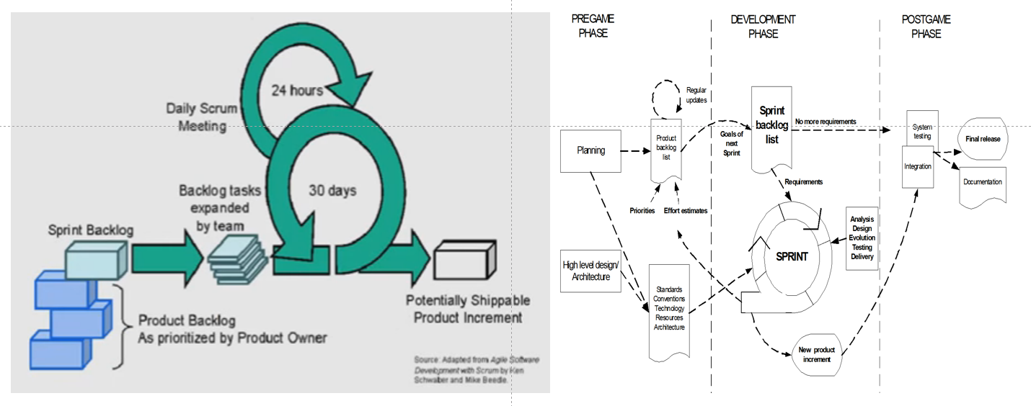Fig 01: Scrum Process Model

In the Pre-game phase, planning and architecture are the primary focus. During planning, the system being developed is defined, and a Product Backlog list is created, containing all the known requirements. These requirements are prioritized, and the effort needed for their implementation is estimated. The Product Backlog is constantly updated with new and more detailed items, as well as with more accurate estimations and new priority orders. Planning also includes the definition of the project team, tools, and other resources, risk assessment and controlling issues, training needs, and verification management approval. Architecture involves planning the high-level design of the system, including the architecture, based on the current items in the Product Backlog. If the project involves enhancing an existing system, the changes needed for implementing the Backlog items are identified along with the problems they may cause. A design review meeting is held to go over the proposals for the implementation, and decisions are made based on this review.  
  
The Development (Game) phase is treated as a "black box" where the unpredictable is expected. The system is developed in Sprints, which are iterative cycles where the functionality is developed or enhanced to produce new increments. Each Sprint includes the traditional phases of software development: requirements, analysis, design, evolution, and delivery phases. One Sprint is planned to last from one week to four weeks, not exceeding one month.

The Post-game phase is entered when an agreement has been made, such as when the requirements are completed. In this case, no more items and issues can be found, nor can any new ones be invented. The system is now ready for release, and the preparation for this is done during the post-game phase, including tasks such as integration, system testing, and documentation.

The Scrum process involves specific roles and responsibilities. The Scrum Master is responsible for ensuring that the project is carried through according to the practices, values, and rules of Scrum and that it progresses as planned. The Scrum Master interacts with the project team as well as with the customer and the management during the project. The Product Owner is officially responsible for the project, managing, controlling, and making visible the Product Backlog list. The Scrum Team is the project team that has the authority to decide on the necessary actions and to organize itself in order to achieve the goals of each Sprint. The customer participates in the tasks related to product Backlog items for the system being developed or enhanced. Management is in charge of final decision-making, along with the agreements, standards, and conventions to be followed in the project. Management also participates in the setting of goals and requirements.  
  
Scrum practices include the Product Backlog & Sprint, where the team adapts to changing environmental variables using Sprint Planning Meetings, Sprint Backlog, and Daily Scrum meetings. Effort Estimation & Sprint Backlog involve selecting Product Backlog items to be implemented in the next Sprint during the Sprint Planning meeting. The Sprint Planning meeting is a two-phase meeting organized by the Scrum Master to decide upon the goals and the functionality of the next Sprint. Daily Scrum meetings are organized to keep track of the progress of the Scrum Team continuously and serve as planning meetings for what has been done since the last meeting and what is to be done before the next one. The Sprint Review meeting is held on the last day of the Sprint, where the Scrum Team and the Scrum Master present the results of the Sprint to the management, customers, users, and the Product Owner in an informal meeting.  
  
We chose Scrum because of its adaptability, which allows us to respond to changing requirements, a common occurrence in software development. The framework's emphasis on collaboration ensures that all team members are aligned and can quickly address any issues that arise. By involving the customer in the process and delivering working software at the end of each Sprint, we can ensure that the final product meets their needs and expectations. The focus on delivering a potentially shippable product at the end of each Sprint helps to maintain a high standard of quality throughout the development process. Scrum's structured approach to development helps to maximize efficiency by minimizing wasted effort and ensuring that the team is always working on the most valuable features. The clear roles and responsibilities, along with regular reviews and meetings, ensure that everyone involved in the project has a clear understanding of progress and any challenges. By choosing Scrum, we aim to create a Coffee Shop Management System that is not only functional and efficient but also aligns closely with the needs of its users, emphasizing flexibility, collaboration, and customer feedback to deliver a high-quality product that meets the specific challenges faced by coffee shops in managing their operations.

# SOFTWARE REQUIREMENTS SPECIFICATIONS (SRS) / PRODUCT REQUIREMENTS DOCUMENT (PRD)

* 1. **Scopes and Features**

The Coffee Shop Management System is designed to be a comprehensive digital solution that addresses the operational challenges faced by small to medium-sized coffee shops. The system scope encompasses the entire lifecycle of coffee shop operations, from inventory procurement to final sales reporting, while providing role-based access to different user categories.

**System Scope:** The system will operate as a centralized web-based application accessible from multiple devices including desktop computers, tablets, and smartphones. It will support single-location coffee shops with the potential for future multi-location expansion. The scope includes managing product catalogs (coffee, tea, pastries, merchandise), processing customer orders through multiple payment methods, tracking inventory levels in real-time, maintaining customer profiles, generating comprehensive business reports, and providing audit trails for all transactions.

The system explicitly excludes features such as advanced accounting (which would integrate with external accounting software), supply chain management beyond basic supplier information, and customer-facing mobile applications (though the web interface will be mobile-responsive). The initial release will focus on core functionalities essential for daily operations, with future enhancements planned based on user feedback.  
  
**Key Features:**

1. User Authentication and Role Management:

* Secure login system with username and password for all user roles
* Role-based access control (RBAC) separating permissions for Admin, Cashier, Inventory Manager, and Customer
* Password reset functionality via OTP sent to registered mobile number and email
* Profile management allowing users to view and update their personal information

2. Admin Dashboard and Control:

* Centralized admin panel with overview of daily sales, inventory status, and staff activity
* Complete product lifecycle management (add, edit, delete products with pricing details)
* Category management for organizing products (e.g., Hot Beverages, Cold Beverages, Snacks)
* Staff account management (create, modify, deactivate cashier and inventory manager accounts)
* Customer data management with viewing and search capabilities
* Access to all bill records and transaction history
* System configuration settings including tax rates and discount rules

3. Cashier Operations Module:

* Streamlined order processing interface for quick customer service
* Product search functionality to rapidly locate items in the catalog
* Shopping cart system to compile multiple items in a single order
* Automatic bill calculation including taxes and discounts
* Multiple payment method support (Cash, Card)
* Digital receipt generation and printing capability
* Order history viewing for reference and reprints
* Customer lookup to associate orders with registered customers

4. Inventory Management:

* Real-time stock level tracking for all products
* Stock count functionality for physical inventory verification
* Automated stock level updates upon sale completion
* Low stock alerts when items fall below defined thresholds
* Stock history tracking to monitor consumption patterns
* Product-wise inventory reports showing current quantities and valuation

5. Customer Self-Service:

* Customer registration with mobile and email verification
* Personal profile management view
* Ability to browse product catalog with current prices
* Shopping cart functionality for order preparation
* Order placement with multiple payment options
* Order history tracking to view past purchases
* Receipt viewing and download capability

6. Reporting and Analytics:

* Daily sales reports showing total revenue, transaction count, and popular items
* Monthly and yearly sales summaries for trend analysis
* Inventory turnover reports to identify fast and slow-moving products
* Profit analysis reports comparing revenue against cost
* Peak hours identification to optimize staff scheduling
* Tax calculation reports for compliance purposes

7. System Integration and Data Management:

* Secure database storage for all business data
* Data backup and recovery mechanisms
* Export functionality for reports in PDF and Excel formats
* Audit trail logging all critical operations for accountability
* Mobile-responsive design for access on various devices

8. Security and Compliance:

* Data encryption for sensitive information (passwords, payment details)
* Session management with automatic timeout for security
* Input validation to prevent SQL injection and cross-site scripting
* Role-based permissions ensuring users only access authorized functions
* Compliance with data protection regulations through proper user consent management